Research Proposal Template

# **Before You Start:**

Please read the following before you start writing your research proposal.

## 1 – Define your research topic first

It’s important to have a crystal-clear research topic in your mind before you start writing your proposal. If you don’t have this, you’ll waste a lot of time on your proposal with rewriting as your topic develops.

If you need guidance/help finding a topic, you can try the following:

1. [Watch our video](https://www.youtube.com/watch?v=hXvoKE6_wQo) covering how to find a research topic
2. [Read our detailed blog post](https://gradcoach.com/how-to-find-choose-dissertation-topic/) covering the same
3. If you’re stuck, [consider engaging with a Grad Coach](https://gradcoach.com/dissertation-topic-help/) to get 1-on-1 help refining your topic

The video and the post mentioned above provide detailed explanations of each of the sections of the proposal, so it would be a good idea to review these as you work through each section.

## 2 – Understand your intended methodology

Explaining how you plan to undertake your research (in other words, your research methodology) is an important part of the proposal. You don’t need to have worked out every single detail, but your university/institution wants to see that you have at least a basic understanding of your intended research methodology, and that it is suitable (given the topic) and manageable (given your resource limits such as time, money and expertise).

So, make sure that you have a clear view of the “how” aspect of your research. If this is still a bit murky, up your knowledge of your intended methodology so that you can speak about it with confidence. There are loads of resources available on Google and YouTube for most popular methodologies and analysis techniques, so you shouldn’t have any problem sharpening your understanding. If you are stuck, you might consider [engaging with Grad Coach](https://gradcoach.com/research-methodology-help/).

## 3 – Check your university’s requirements for the proposal

While there are standard requirements for a research proposal (which we include in this template), every university has slightly different requirements and expectations, especially in terms of how long the proposal should be.

Make sure you understand what your university requires, or you’ll end up wasting a lot of time.

# **Provisional Title or Title Page**

The starting point for your research proposal is a clear, descriptive title. This title should give the first-time reader a big-picture idea of what the research will be about, in a line or two.

Generally, a good research title provides insight into (at least) X things:

1. What’s being researched (i.e. the variables involved)
2. Who it involves (i.e. the group of people being researched)
3. What context it’s in (e.g. a country or industry)
4. What methodology will be adopted (e.g. qualitative or quantitative

For example:

*“A quantitative investigation into the drivers of brand advocacy amongst middle-aged female cosmetics consumers: a British context”*

As you can see, this covers all the bases mentioned above.

Keep in mind that this is just a provisional title – it can (and probably will) change as your thinking develops and your research progresses.

# **Introduction & Background**

Now that your title has given the reader a taste of what your research will be about, the “Introduction & Background” section needs to explain your research topic in more detail, justify why you’re researching it, and outline the specific research aims, objectives and research questions.

You should cover the following here:

* An overview of the broad area you’ll be researching – introduce the reader to key concepts and language
* An explanation of the specific (narrower) area you’ll be focusing, and why you’ll be focusing there. Make it clear what the research problem is, what the gap in the literature is, and why your research is important.
* Your research aims and objectives
* Your research question(s) and sub-questions (if applicable).

In this section, it’s also a good idea to define the boundaries of your research (what we typically call “scope”). In other words, be clear about not just what your research WILL cover, but also what it WON’T cover. It’s important for you to have a clear, narrow focus when undertaking research, so don’t be afraid to keep your scope narrow and go deep into one specific area.

As mentioned earlier, be sure to check exactly what your university expects in terms of your proposal. Some universities will want you to discuss other matters in this section. For example, personal development objectives, links to the course module material, etc. Also, some universities will want a dedicated section covering the problem statement, as opposed to having it woven into this section.

# **Literature Review**

The next section that you need to cover is the provisional literature review. Generally, it’s not expected that you’ve done an extremely in-depth literature review at the proposal stage, but you do need to show that you’re familiar with the literature around your topic, and that you’ve identified a clear research gap.

Literature reviews can take many shapes and formats, so it’s difficult to prescribe a universal structure for this section. Generally, it’s wise to start by providing clear definitions for any key items being research. But beyond this, the structure will vary dependent on the research topic.

Some literature reviews will take a chronological approach (discussing the evolution of the research over time), while others will group literature into bundles reflecting the variables being researched.

For example, if a study was investigating the drivers of trust in a certain context, the literature review might be broken into groups reflecting each potential driver – competence, benevolence and integrity.

Importantly, your literature review needs to achieve the following:

1. It needs to show that you have identified and are **familiar with the key literature** in your research area
2. That you have identified a **clear and important research gap**, which then forms the basis of your research topic
3. That you’ve considered the **methodologies** used in the existing research, and that this has informed your thinking for your own research

Tip - When you’re working your way through the literature review, make sure that you maintain a well-organised catalogue of your literature, as you will come back to your literature many times throughout the process. Your collection will grow substantially over time and you won’t remember the finer details of each journal article, so keeping a catalogue is essential. If you don’t have a catalogue, you can download our [free literature review Excel template here.](https://gradcoach.com/literature-review-excel-template/)

If you’re unsure how to undertake a literature review, consider the following:

1. [Watch our detailed video](https://www.youtube.com/watch?v=lw8HPXJP1VA) covering the literature review process
2. [Read our post covering the same](https://gradcoach.com/how-to-write-a-literature-review/)
3. If you’re stuck, [consider engaging with a Grad Coach](https://gradcoach.com/dissertation-topic-help/) to get 1-on-1 help refining your topic

# **Research Design / Methodology**

Now that you’ve provided a concise overview of the existing research in your literature review section, you need to explain how you will undertake your own research – in other words, your methodology.

As mentioned earlier, given that this is just a proposal, universities generally don’t expect that you have an in-depth understanding of your research methodology at this stage. However, they do want to see that you have a basic understanding of your intended research methodology, and that it is suitable (given the topic) and manageable (given your resource limits such as time, money and expertise).

In this section, you should address (at least) the following:

* Will you take a qualitative or quantitative approach?
* Will your design be cross-sectional or longitudinal?
* Who will you collect data from (your sample)?
* How will you collect your data (interviews, surveys, etc)?
* How will you analyse your data (e.g. statistical analysis, qualitative data analysis, etc)?

If you are able to provide more detail than this, it would be good to do so, as it shows the reader that you have given extensive thought to your design already, and that you’re confident that you can actually pull it off. However, make sure that you know what you’re talking about. If you throw around big words and technical terms that you don’t fully understand, it will be very obvious to the reader.

# **Practicalities / Project Management**

As we’ve mentioned earlier, your university will want to be sure that your proposed research is manageable and achievable, given your constraints such as time, money and expertise. This section should address exactly that, provided a clear plan of action for your research, should it be approved.

You should consider including the following here:

1. A clear **project plan** that outlines the major steps and stages in your research, with well-defined, realistic timelines. A Gantt chart can be very useful for this.
2. A **budget** (if you require financial resources) or equipment list (if you require lab equipment), and a clear explanation of how you will secure the required resources.
3. A **risk register**, which clearly identifies the main risks involved in your project, what the likelihood and impact are for each, and how you plan to manage these should they arise.
4. A discussion of any research ethics-related matters. Check what your university’s research ethics requirements are before you start drafting your proposal, as this can have a major impact on your plans.

Below: an example Gantt chart for a research project:

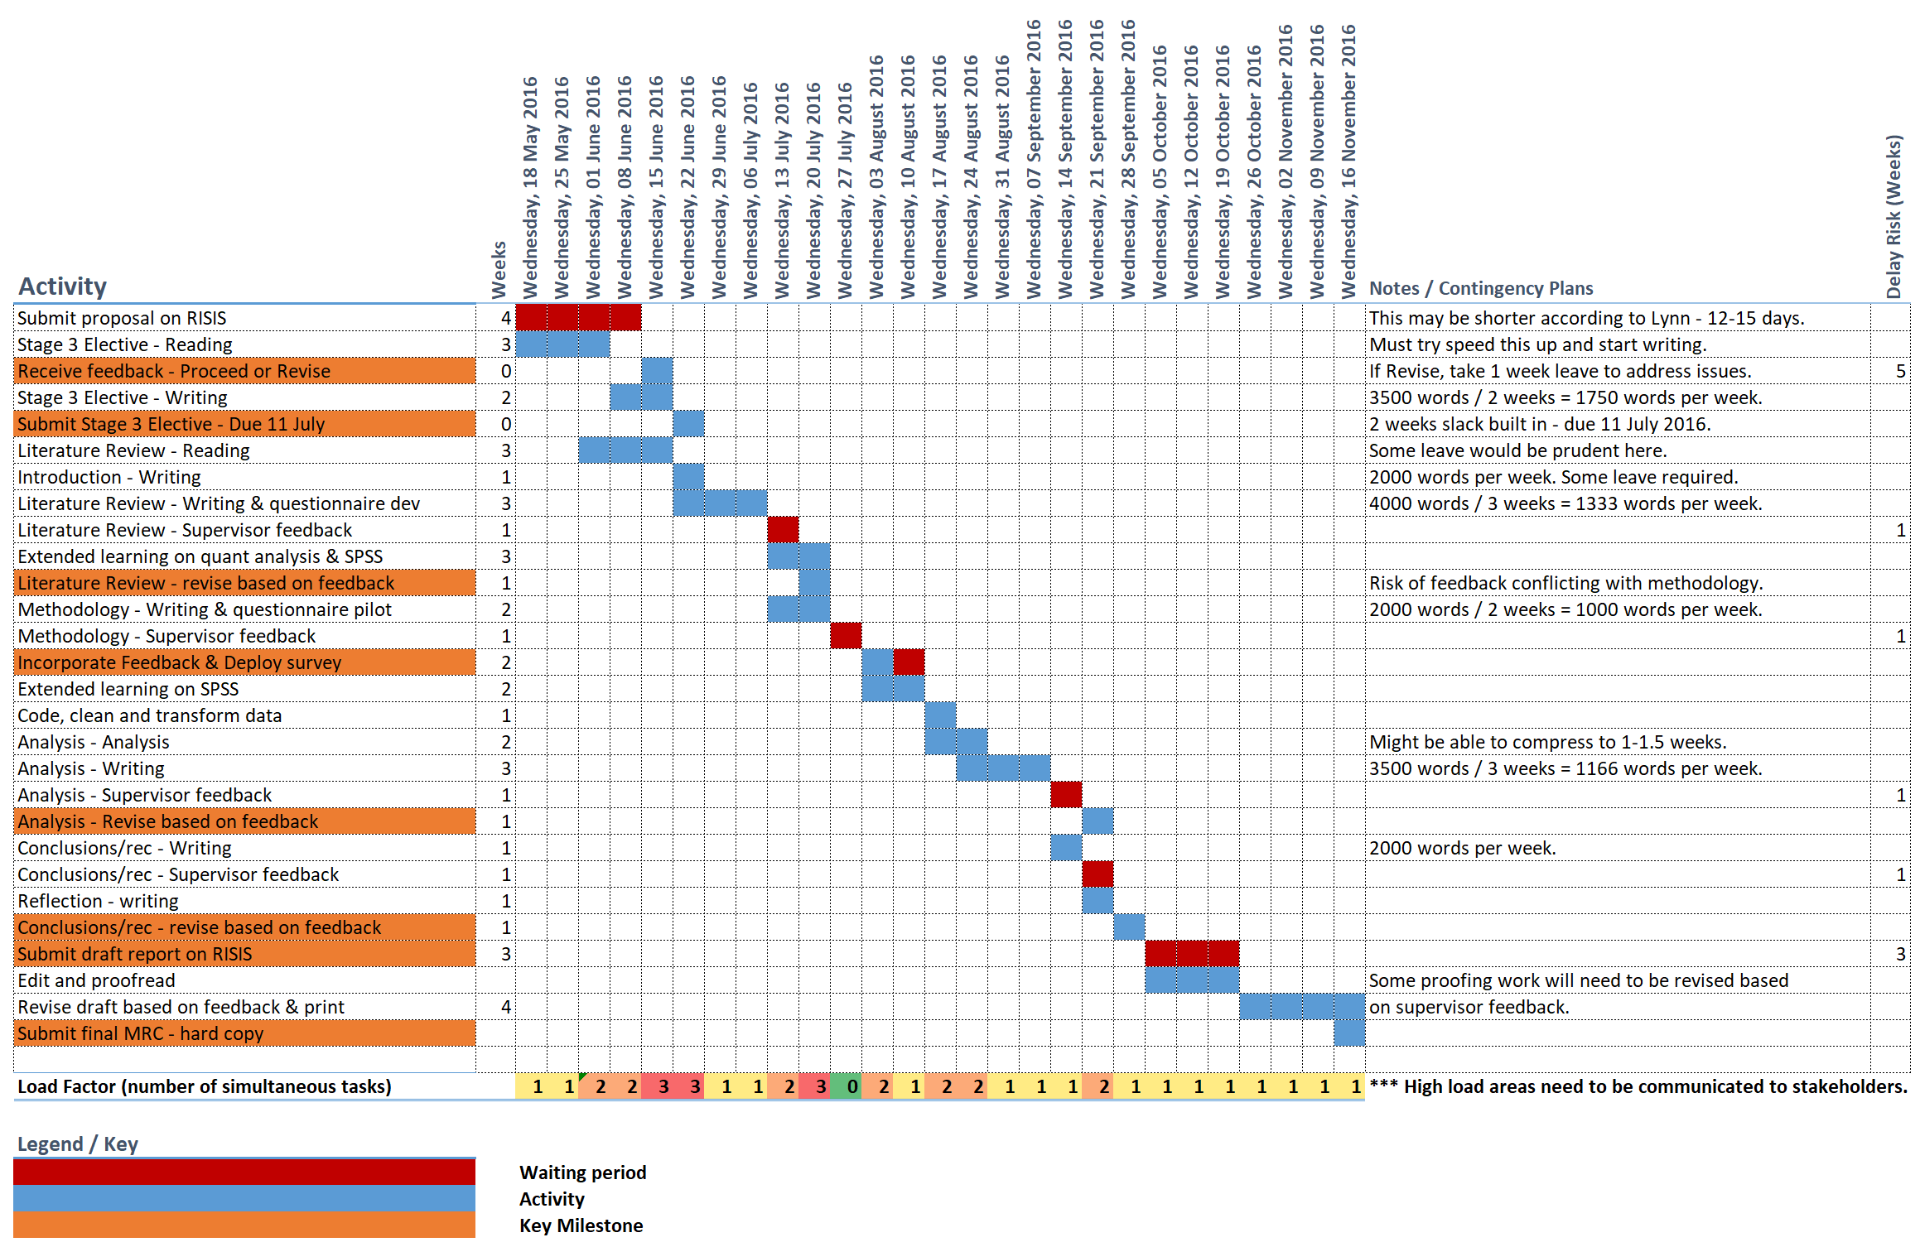

# **Other**

As mentioned, this template only covers the common essential ingredients of a typical research proposal for a dissertation or thesis. Be sure to check what your university’s specific requirements are, as you may need to include additional sections or structure things a little differently.

# **Reference List**

Given that this is an academic document, a full reference list is typically required. Be sure to follow whichever citation and reference format your university requires (for example, Harvard referencing).

If you don’t yet use a reference management software, we recommend using Mendeley or Zotero. They are both free to use and ensure that your referencing is always 100% on point. You can learn about both in our “how to” videos:

* How to use Mendeley - <https://www.youtube.com/watch?v=XTfVCiksapk>
* How to use Zotero - <https://www.youtube.com/watch?v=C0RrNu89oAM>

# **Appendices**

Depending on your university’s requirements, you may need to also include supporting documentation. Any such document will go into the appendices. Remember to refer to any appendix in the body.